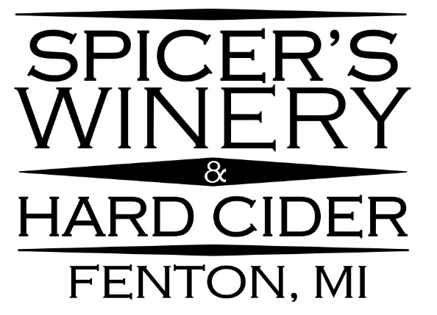
Private Event Options!
Want more Spicer’s Winery? Schedule a unique, after-hours Private Wine Tasting in our tasting room; a great atmosphere for special occasions such as birthdays, family & friend celebrations, bridal showers, bachelorette parties or simply a girl’s/guy’s night out - perfect for any level of wine or hard cider enthusiast. We comfortably host groups of 10-25 people!

Customize Your Spicer’s Winery Private Event! _{(25 Person Maximum)}

Start by deciding how much time you want spend with us after regular business hours end!
Choose 2 hours ($200 facility rental) just for you and your guests!
Or 3 hours for $275!

Next, decide if your guests would prefer our tasting package or a cash bar!
$12 per person Tasting Package Includes:
- 7 - 1oz tastes of wine and hard cider
- 1 - 7oz glass of favorite variety after the tastings are complete
- 1 - 6oz Souvenir Glass to keep

Add cheese platters and dessert to any Private Event!
- Large Platter of Meats, Cheeses, & Crackers for $25 Each
(1 platter serves about 5 guests)
- Gourmet desserts prepared by our in-house pastry chef & chocolatier Andrea DeVisser are available to custom order!
(Dessert Menu & Pricing – see Pg.8)

Want to add a catered dinner? Make your party an Exclusive Wine & Dine Event! (10 Person Minimum, 16 Person Maximum)
- 3 Hour Facility Rental for $275
- Cash bar option or our $12 per person tasting package (see above)
- Dinner package of your choice from The Laundry
(Dinner menu Pg.6-7, prices may vary.)
- Add cheese platters and/or dessert

NEW: Murder Mystery Adventure! (6 Person Minimum, 20 Person Maximum) by Shot in the Dark Mysteries *More details about new options on separate page.
NEW: Uncorking Creativity - Wine Glass Painting class! (8 Person Minimum, 18 Person Maximum) *More details about new options on separate page.
Contact the Winery Event Coordinator for more information!

wineryevents@spicerorchards.com 810-632-7692
Spicer’s Winery Private Events!
NEW: Murder Mystery Adventure! (6 Person Minimum, 20 Person Maximum)
by Shot in the Dark Mysteries “Our mysteries create an actual investigation at your party – no silly stunts or ridiculous lines – just straight-up sleuthing to find who had the motive, means and opportunity to commit the murder or theft.”
- 3 Hour Facility Rental for $275
- murder mystery investigation game for $25 per person – Can you and your guests solve the puzzle?
- 2 glasses of wine or hard cider per person included!
- Guests 21 and over welcome!
- No prior experience necessary!

Add cheese platters and dessert to any Private Event!
- Large Platter of Meats, Cheeses, & Crackers for $25 Each
(1 platter serves about 5 guests)
- Gourmet desserts prepared by our in-house pastry chef & chocolatier Andrea DeVisser are available to custom order!
(Dessert Menu & Pricing – see attached)

Mystery Themes: (Please decide 2 weeks prior to event – Options may vary based on number and gender of guests attending) Questions? Ask the winery event coordinator for more information!
- Murder at the Winery (Vineyard in Italy)*
- A Flapper Murder at the 1920’s Speakeasy!*
- The Bachelorette Party Murder Mystery*
- The Winter Wonderland Murder Mystery (Christmas Party with celebrities and socialites!)*
- The Masquerade Murder Mystery (The Da Vinci Code – Venice)*
- Garden Party Murder Mystery*
- Murder in the Alps (Ski Chalet)
- Murder at the 1980’s prom
- A Steampunk Murder Mystery Party (1857 – London’s Old Town)
- Murder in Wonderland (Alice!)
*All female story options available on select themes!
Scheduling Information:
To book a private party, we require:
- a $50 deposit to reserve your event date
- a final head count and any custom orders 2 weeks before the party date
- To help facilitate a smooth event and relaxing atmosphere for your group, we ask that the remaining balance due is paid as one transaction upon arrival

Contact the Winery Event Coordinator for more information!

wineryevents@spicerorchards.com 810-632-7692
Spicer’s Winery Private Events!
NEW: Uncorking Creativity - Wine Glass Painting class! (8 Person Minimum, 18 Person Maximum)
- 2 Hour Facility Rental for $200
- Instruction, Wine Glass, & Painting Supplies for $25 per person
- 2 glasses of wine or hard cider per person included!
- Guests 21 and over welcome!
- No prior experience necessary!

Add cheese platters and dessert to any Private Event!
- Large Platter of Meats, Cheeses, & Crackers for $25 Each
(1 platter serves about 5 guests)
- Gourmet desserts prepared by our in-house pastry chef & chocolatier Andrea DeVisser are available for custom order!
(Dessert Menu & Pricing – see attached)

Uncorking Creativity Themes: (please decide 2 weeks prior to event)
- Spring/Summer Theme:
  - St. Patrick’s Day
  - Easter
  - Sunflower
  - Fireworks (Fourth of July Theme)
  - Watermelon
  - Sunset/ water
  - Sea Turtle
  - Beach/ Starfish
  - Pineapple
  - Baseball

- Fall/ Winter Theme:
  - Back to school/ Teacher
  - Leaves
  - Pumpkin
  - Football
  - Halloween
  - Thanksgiving
  - Christmas tree
  - Christmas lights
  - Snowman
  - Santa
  - Snow Flakes
  - Valentine’s Day

- Special Event:
  - Girls/Guys Night
  - Birthday
  - Wedding/ Bachelorette Party

Contact the Winery Event Coordinator for more information!

wineryevents@spicerorchards.com 810-632-7692
Spicer’s Winery Private Events!

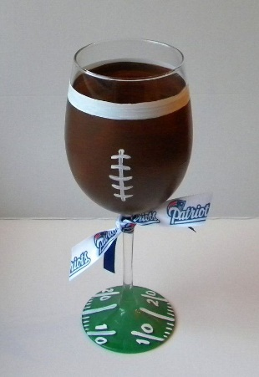
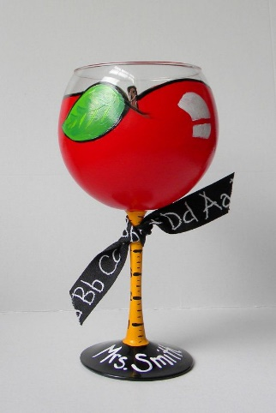
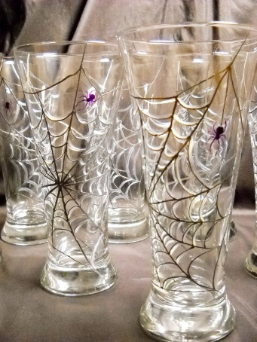
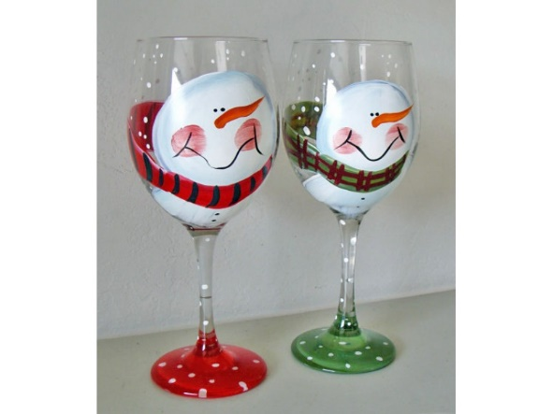
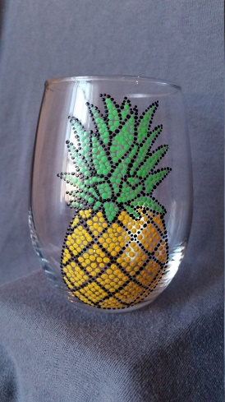
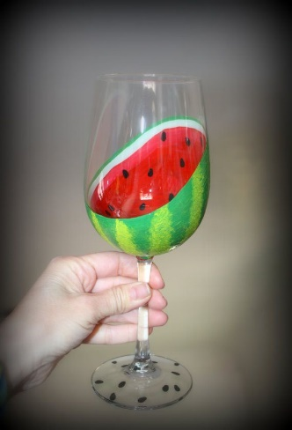

Contact the Winery Event Coordinator for more information!

wineryevents@spicerorchards.com 810-632-7692

Scheduling Information:
To book a private party, we require:
- a $50 deposit to reserve your event date
- a final head count and any custom orders 2 weeks before the party date
- To help facilitate a smooth event and relaxing atmosphere for your group, we ask that the remaining balance due is paid as one transaction upon arrival

to schedule your Spicer’s Winery private event, Contact us at wineryevents@spicerorchards.com
or call 810-632-7692 and ask for the Winery Event Coordinator!

Frequently Asked Questions:
- Is the $50 Deposit refundable?
  - Yes, if you cancel more than 2 weeks before your scheduled event date. Deposit is non-refundable 14 days before event. No exceptions.

- Is the $50 Deposit a separate fee or will it be applied to the private event total bill?
  - The $50 Deposit will be applied to the total bill.

- Can I book a private party in the afternoon?
  - Since our private events are held inside the tasting room, private parties may not be held while we are open for regular business hours. Available start times may vary due to seasonal business hours.

- Will I be able to drive myself home safely after a private wine tasting event?
  - To ensure the safety of all of the guests and the community, we recommend having transportation (designated drivers, cabs, people to drop off and return to pick up, or a party bus, etc.,) arranged for your guests, as each person metabolizes alcohol differently.

- My family/friends are planning to go out to dinner before attending a private wine tasting event. Is it ok to have a drink or two while we’re out to eat?
  - we recommend guests do not consume any alcohol immediately prior to attending our private wine tasting events.

- I’m interested in renting Spicer’s Winery for my special event, but I’m not sure if I want to add on the tasting package for $12 per person. Can I still have my private party at the winery?
  - Yes! You do not have to add the tasting package to host your special event here after regular business hours end for the day. You can rent our tasting room for 2 hours for $200, or 3 hours for $275 and your guests can purchase wine & hard cider from the cash bar.

We reserve the right to refuse service and/or refund to noticeably intoxicated guests upon arrival.

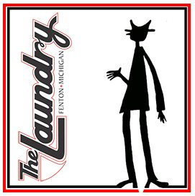
Delicious and delectable Wine and Dine food options provided by
The Laundry, of Fenton, MI!

125 W. Shiawassee at Adelaide
Fenton, Michigan 48430
810-629-8852
PRICES MAY VARY

Backyard Party
Whether celebrating a July birthday or hosting an open house for the son who finally finished college, this menu is casual but impresses the masses.
- Herb-Roasted Chicken
- BBQ Pulled Pork with mini brioche buns
- Picnic Potato Salad
- Roasted Vegetables
- Fresh Fruit
$22.95+TAX per person
Family Dinner
Comfort food at its best. Take the stress out of the family get-together and still make ‘em feel at home.
- Choice of Yankee Pot Roast, Bacon-Wrapped Meatloaf or Herb-Roasted Chicken
- Butter and sour cream mashed potatoes
- Roasted seasonal vegetables
- Tossed green salad
$19.50+TAX per person

Pasta Party
A fun and economical way to feed a large, hungry group without sacrificing great flavor.
- Choice of Penne Pasta Primavera, Agilo e Aioli or Vegetable Lasagna
- Tossed Green Salad
- Simple bruschetta
$17.95+TAX per person

Sammie Spread
Our most popular sandwiches and salads in one easy package. Great for tailgating or feeding the office at lunchtime.
- Assorted deli sandwiches (Choose from The Laundry’s most popular sandwiches: #1, 7, 11, 12, 21, 28, 37, 38, 40, 52 and 66. Descriptions provided on next page)
- Picnic Potato Salad
- Coleslaw
- Pickles
$19.50+TAX per person

No Stress to Impress
This simple, classic meal will impress the diehard foodie and those with the simplest taste buds. Sure to please any crowd.
- Choice of Roasted Beef Tenderloin with red wine demi-glace or Baked Salmon with lemon butter sauce
- Dauphinoise potatoes – sliced Idaho potatoes layered with egg custard and Gruyère and Parmesan cheeses
- Green beans with Parmesan and slivered almonds
- Caesar salad
Roasted Beef Tenderloin market price +TAX per person
Baked Salmon $34.95+TAX per person

Sammie Spread Sandwich Options:
#1 BLT
Nueske’s applewood smoked bacon, lettuce, tomato and mayo on fresh Bowery Rye.

#7 He Ain’t Heavy
Smoked turkey, Nueske’s applewood smoked bacon, Muenster cheese, lettuce, mayo, and honey mustard on an onion roll.

#11 Reuben
Warm house-boiled corned beef, Emmentaler cheese, sauerkraut and housemade Russian dressing on grilled Bowery Rye.

#12 Georgia Reuben
Turkey breast, Emmentaler cheese, cole slaw, and Russian dressing on grilled Bowery Rye.

#21 Jacques Brel is Alive and Well and Living in Fenton
Nueske’s pit-smoked peppered ham, smoked turkey breast, Nueske’s applewood smoked bacon, Switzerland Swiss cheese, lettuce, tomatoes, and mayo on soft Challah bread.

#28 Ron’s Lifesaver
Smoked turkey breast, Vermont cheddar, lettuce, tomatoes, sweet red onions, mayo, and Italian pesto on grilled Henry St. Provincial bread.

#37 The Peeping Chicken
Grilled chicken, hummus, honey mustard, fresh spinach, roasted red peppers, red onions, cucumbers on grilled Downtown Brown bread.

#38 Tiffany “Fweef” Salcini
Warm pastrami, red onions, scallion cream cheese, jalapeño peppers, and honey mustard on grilled Kulbok Dark Rye.

#40 The Floydian Slip
Our homemade chicken salad, Zingerman’s natural cream cheese, raspberry preserves from CRUST, red onions, and lettuce in a whole wheat wrap.

#52 Rabbit Food Roll Up (no meat)
Chopped Romaine lettuce, Vermont cheddar, red onion, tomatoes, hard-boiled egg, fresh avocado, crumbled black bean tortilla chips, peas and house-made ranch rolled up in a whole wheat wrap.

#66 Give Me the Skinny on That
Smoked turkey breast, Emmentaler cheese, honey mustard, cucumbers, and lettuce, on thinly sliced Henry St. Provincial bread.

D

esserts
e Visser
Cheesecake [$35.00] 9” serves approx. 16
__Chocolate
__Vanilla
__Turtle
__ Strawberry
__ Chocolate Raspberry
__Caramel Apple
__ Pumpkin

Cupcakes [$27/ dozen] Minimum order of one dozen
__Chocolate
__Vanilla
__Salted Caramel
__Red Velvet
__Carrot
__ Strawberry
__Caramel Apple
__ Pumpkin

Mini Desserts [$1.35 each] It is best to account for 3 mini desserts per person
*Flavors listed in above categories
__Chocolate Covered Strawberries
__Chocolate Covered Oreos
__Pecan Diamonds
__Coconut Macaroons
__Turtles
__Cheesecake Bites*
__Mini Cupcakes*

Party Favors [$7.95 each] No minimum order
__Chocolate Covered Caramel Apples (Decorated and packaged in clear cello bags)

Visit www.devisserdesserts.com for more information

Spicer’s Winery Private Event Form
To fully serve your needs, please fill out form completely:

Event Type: Wine Tasting, Wine & Dine, Cash Bar
Themed Menu Option (For Wine & Dine Only):
Occasion:
Host Name:
Contact Phone:
E-mail:
(Email address will be used to send written confirmation of private event details after booking)
Date of Event:
Date Final Head Count Required:
(Final Head Count Required 2 Weeks Prior to Event)
Start Time: 7pm, 7:30pm, or 8pm
(Available start times may vary due to seasonal business hours)
End Time:
(2 Hour Party for $200 or 3 Hour Party for $275; + per person options)
Number of Guests:
Please be advised that host is responsible for payment. Please have any cash collected from guests ready to make final payment as one transaction at the start of the event. Thank you! |  |  |  |  | Please initial:
DEPOSIT REQUIRED: Amount: $50 | Paid on: _____/_____/_____
All Special Requests:
Facility Rental Fee (2 Hours $200 or 3 Hours $275): |  | # of Hours:
Tasting Package ($12 per person): |  |  | Quantity: |  | $0.00
Meat & Cheese Platters ($25 each): |  |  | Quantity: |  | $0.00
Wine & Dine Menu Option:
DeVisser Desserts Order:
Any Additional Extras:
Subtotal: |  |  |  |  | $0.00
Prepaid Deposit Credit:
Total Due At Start of Private Event: |  |  |  |  | $0.00
For questions or concerns regarding your private event, please contact us at
810-632-7692 and ask to speak with the Winery Event Coordinator. Thank you for choosing Spicer’s Winery. We look forward to meeting you & hosting your special event!

Example Private Event Form
Event Type: Wine Tasting, Wine & Dine, Cash Bar |  |  | Wine & Dine
Themed Menu Option (For Wine & Dine Only): |  | No Stress to Impress w/Salmon
Occasion: |  |  | 40th Birthday
Host Name: |  |  | Vicky Vino
Contact Phone: |  |  | 810-555-5555
E-mail: |  | vickyvino@randomemail.com
(Email address will be used to send written confirmation of private event details after booking)
Date of Event: |  |  |  | 4/7/2018
Date Final Head Count Required:
(Final Head Count Required 2 Weeks Prior to Event) |  |  |  | 3/24/2018
Start Time: 7pm, 7:30pm, or 8pm |  |  |  | 7:30pm
(Available start times may vary due to seasonal business hours)
End Time: |  | 3 Hour Party |  | 10:30pm
(2 Hour Party for $200 or 3 Hour Party for $275; + per person options)
Number of Guests: |  |  |  | 16
Please be advised that host is responsible for payment. Please have any cash collected from guests ready to make final payment as one transaction at the start of the event. Thank You! |  |  |  | Please initial: VV
DEPOSIT REQUIRED: Amount: $50 | Paid on: _02/15/2018_
All Special Requests:
1 - chocolate raspberry cheesecake ($35)
Facility Rental Fee (2 Hours $200 or 3 Hours $275): |  | # of Hours: | 3 | $275.00
Tasting Package ($12 per person): |  | Quantity: | 16 | $192.00
Meat & Cheese Platters ($25 each): |  | Quantity: | 3 | $75.00
Wine & Dine Menu Option: (Prices may vary) |  | 16@34.95+Tax |  | $592.75
DeVisser Desserts Order: |  |  |  | $35.00
Any Additional Extras:
Subtotal: |  |  |  | $1,169.75
Prepaid Deposit Credit: |  |  |  | -$50.00
Total Due At Start of Private Event: |  |  |  | $1,119.75
For questions or concerns regarding your private event, please contact us at
810-632-7692 and ask to speak with the Winery Event Coordinator. Thank you for choosing Spicer’s Winery. We look forward to meeting you & hosting your special event!

